***PAAREES PERFUMES***

***DAVIDOFF***

***FOR UNISEX***

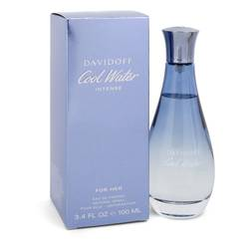

# *Cool Water Intense*

***Description:***

Cool Water Intense by Davidoff Perfume. Cool Water Intense is a new fragrance, having just hit the market in 2019. This floral and fruity scent will have you feeling like you are in a tropical paradise. It begins with mandarin harvested from a community in Brazil. Mangosteen in the heart combines with the paradise flower in the base to create a feminine and empowering perfume.  
  
Davidoff began as a luxurious men's brand, selling writing instruments, cognac and other high-end goods. The company's legendary founder was known for traveling the world in search of the best ingredients to use in his products. The business continues this legacy and strives for perfection, authenticity and reliability. The Swiss-based family brand first entered the world of fragrance in 1984. Then, in 1988, it released its Cool Water cologne, which became one of the most popular scents ever. The company subsequently launched numerous men's and women's offshoots of this scent, including Cool Water Game and Cool Water Frozen.